|  |  |
| --- | --- |
| Pandas Challenge Check box | |
|  | 1. District Summary |
| x | * 1. Create a high level snapshot (in table form) of the district's key metrics, including: |
| x | * + 1. Total Schools |
| x | * + 1. Total Students |
| x | * + 1. Total Budget |
| x | * + 1. Average Math Score |
| x | * + 1. Average Reading Score |
| x | * + 1. % Passing Math (The percentage of students that passed math.) |
| x | * + 1. % Passing Reading (The percentage of students that passed reading.) |
| x | * + 1. % Overall Passing (The percentage of students that passed math **and** reading.) |
|  |  |
|  | 1. School Summary |
|  | * 1. Create an overview table that summarizes key metrics about each school, including: |
| x | * 1. School Name |
| x | * 1. School Type |
| x | * 1. Total Students |
|  | * 1. Total School Budget |
|  | * 1. Per Student Budget |
|  | * 1. Average Math Score |
|  | * 1. Average Reading Score |
|  | * 1. % Passing Math (The percentage of students that passed math.) |
|  | * 1. % Passing Reading (The percentage of students that passed reading.) |
|  | * 1. % Overall Passing (The percentage of students that passed math **and** reading.) |
|  | 1. Top Performing Schools (By % Overall Passing) |
|  | * 1. Create a table that highlights the top 5 performing schools based on % Overall Passing. Include: |
|  | * 1. School Name |
|  | * 1. School Type |
|  | * 1. Total Students |
|  | * 1. Total School Budget |
|  | * 1. Per Student Budget |
|  | * + 1. Average Math Score |
|  | * + 1. Average Reading Score |
|  | * + 1. % Passing Math (The percentage of students that passed math.) |
|  | * + 1. % Passing Reading (The percentage of students that passed reading.) |
|  | * + 1. % Overall Passing (The percentage of students that passed math **and** reading.) |
|  | * + 1. Bottom Performing Schools (By % Overall Passing) |
|  | 1. Create a table that highlights the bottom 5 performing schools based on % Overall Passing. Include all of the same metrics as above. |
|  | * 1. Math Scores by Grade\*\* |
|  | 1. Create a table that lists the average Math Score for students of each grade level (9th, 10th, 11th, 12th) at each school. |
|  | * 1. Reading Scores by Grade |
|  | 1. Create a table that lists the average Reading Score for students of each grade level (9th, 10th, 11th, 12th) at each school. |
|  | * 1. Scores by School Spending |
|  | 1. Create a table that breaks down school performances based on average Spending Ranges (Per Student). Use 4 reasonable bins to group school spending. Include in the table each of the following: |
|  | * 1. Average Math Score |
|  | * 1. Average Reading Score |
|  | * 1. % Passing Math (The percentage of students that passed math.) |
|  | * 1. % Passing Reading (The percentage of students that passed reading.) |
|  | * 1. % Overall Passing (The percentage of students that passed math **and** reading.) |
|  | * 1. Scores by School Size |
|  | 1. Create a table that breaks down school performances based on average Spending Ranges (Per Student). Use 4 reasonable bins to group school spending. Include in the table each of the following: |
|  | * 1. Average Math Score |
|  | * 1. Average Reading Score |
|  | * 1. % Passing Math (The percentage of students that passed math.) |
|  | * 1. % Passing Reading (The percentage of students that passed reading.) |
|  | * 1. % Overall Passing (The percentage of students that passed math **and** reading.) |
|  | * 1. Scores by School Type |
|  | 1. Create a table that breaks down school performances-based school type (Per Student). Use public, charter |
|  | * 1. Average Math Score |
|  | * 1. Average Reading Score |
|  | * 1. % Passing Math (The percentage of students that passed math.) |
|  | * 1. % Passing Reading (The percentage of students that passed reading.) |
|  | * 1. % Overall Passing (The percentage of students that passed math **and** reading.) |
|  | * 1. As final considerations: |
|  | 1. *Use the pandas library and Jupyter Notebook.* |
|  | * 1. You must submit a link to your Jupyter Notebook. |
|  | * 1. You must include a written description of at least two observable trends based on the data. |
|  | * 1. See [Example Solution](PyCitySchools/PyCitySchools_starter.ipynb) for a reference on the expected format. |
|  |  |

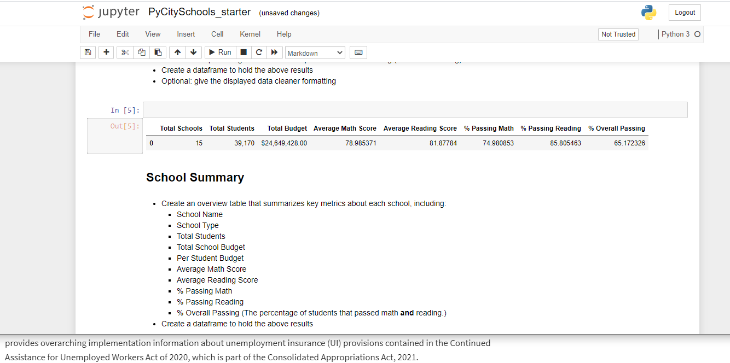

combo_reading_math_passing_grade_df = pass_grades_math_df.loc[pass_grades_math_df["reading_score"] >= 70]

combo_reading_math_percent = (combo_reading_math_passing_grade_df.reading_score.count() / student_data_df.student_name.count())*100

combo_reading_math_percent

